ESCAP/WMO Typhoon Committee Integrated Workshop
“Urban Flood Risk Management in a Changing Climate: Sustainable and Adaptation Challenges”
06-10 September 2010 Macao, China
Hydrology Assessment
Prepared by Royal Irrigation Department, Thailand
TOPICS
- Urban Flood Risk Management
Case study 1: Flood Risk Management in Hat Yai, Thailand
- Introduction
Hat Yai, the largest commercial and tourist city in southern Thailand, is subject to regular flood events, primarily during the north-east monsoon period. Serious flooding occurred in 1988 and again in 2000. Flooding in this city is recognized as a serious disaster in terms of the frequency, level of risk, and affected areas.
The city of Hat Yai is located in low-lying areas at the base of a roughly circular valley. It is also prone to inundation from the Utaphao River, which flows through its heart, often in concrete channels that provide limited drainage. The Utaphao river basin is located in southern Thailand (Figure 1). The river rises at Sadao, on the border with Malaysia, and flows generally northwards to meet Songhkla lake. This lake is in fact a coastal lagoon, important for fishing, which is hydraulically connected to Gulf of Thailand. Just upstream of its outfall into Songkhla lake, the river runs through the important commercial city of Hat Yai, a rapidly growing urban area with a high population density. Through Hat Yai the river runs mainly in a man-made drainage channel of limited drainage capacity. The catchment area of the river at Hat Yai is approximately 2,500 km².
In 1988, flooding in the Utaphao River Basin caused damages more than 4,000 million Baht. In November of 2000 a major flood, caused by extremely heavy rain in the southern part of Thailand, resulted in a serious flood affecting Hat Yai. Many areas of Hat Yai city were inundated under flood waters. Flood inundation lasted for up to seven days at the same location, with flood depths of two to three metres being recorded. In one night, flood waters in Hat Yai rose half a metre, bringing water levels up to 2.5 metres. Many basements were flooded for up to three weeks. Over one hundred fatalities were recorded, although the exact figure will never be known. The economic flood damage, especially to rubber and palm oil crops, was extensive. This caused significant damages of more than 10,000 million Baht. Such serious flooding has a major impact on livelihoods, as well as seriously affecting the city's economy and infrastructure (Figure 2).
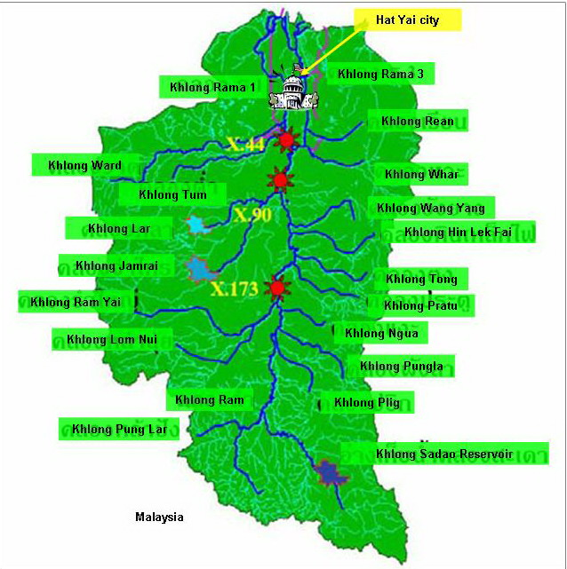
Malaysia
Figure 1 Location of Utaphao river basin and characteristic of the river basin.

Figure 2 Flood Situation in Hai Yai city.
- Flood Mitigation of Utaphao river basin and Hat Yai city
As a result of the severe flood event of 2000, a decision was made to develop a comprehensive Flood Mitigation Project for the Utaphao River Basin and Hat Yai city areas. The government has implemented the King of Thailand’s concept for flood relief and mitigation in Utaphao river basin by 2 measures; structural and non-structural measures.
1. Structural measures (refer to Figures 3 and 4)

- Improvement of natural water drainage system, natural canal extension to improve drainage efficiency of klong Utaphao, Utaphao 1, Utaphao 2 and Tachang-Bangklum canal for a distance of 46.90 km.
- Flash flood drainage management, main drainage system work (King Rama 1 drainage canal) including a water gate to transfer water from Utaphao canal to Songkhla lake (length 21.343 km). A water diversion canal (length 26 km) and water gate will drain water from Utapho canal outside Hat Yai town and relief flood in the lower Utaphao canal.
- A diversion canal was built to discharge excess flow directly to the sea. A sea barrier was built to prevent tidal effects which prevent the excess runoff to enter the sea. Construction of embankments, improvement of drainage canals
- Reservoir area improvement
- Reservoir area water way construction
- Provision of drainage pumps.

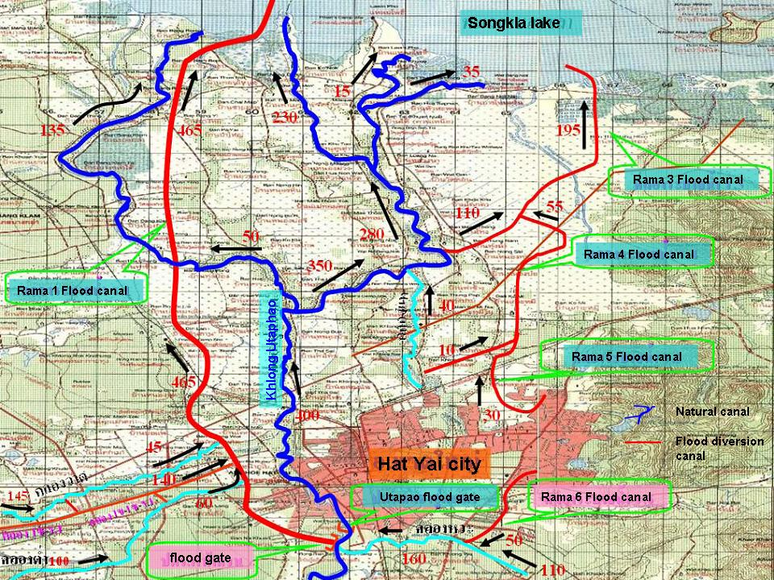

Figure 3 Flood canals for the Utaphao river basin

Flood gate in sub-canal
Diversion canal
Flood gate in main canal
Diversion sub-canal

Figure 4 Some flood control structures in the Utaphao River Basin

2. Nonstructural measures

- Monitoring the climatic (e.g. typhoon track, rainfall forecast etc) and hydrologic situation (e.g. river and reservoir levels) of the Utaphao River using information from Thai meteorology websites as well as foreign websites (e.g. NASA, NOAA).
- Watershed water management to aid in the flood warning and mitigation of floods. This includes public warning for advance flood preparation to relive the damage caused to properties and human lives.
- Water analysis center at Songkhla Irrigation project.

- Utaphao River Basin Telemetry System
The real-time telemetry system in the Utaphao River Basin consists of one main station and 13 field stations (Figure 5). It measures rainfall and discharge every 15 minutes. The data are sent via a VHF radio network to the main station for data analysis and flood prediction. Flood warning is provided 9 to 16 hours in advance. The main station is at Irrigation office 16, Songkhla province. The 13 field stations are at X.194, X.181, X173A, X.44, X.90, Klong Whar, Klong Hoi Kong, Klong Nang Ram Yai, Klong Sadao dam. The efficiency of the telemetry system will be increased when we add a GPRS system and 5 more field stations.
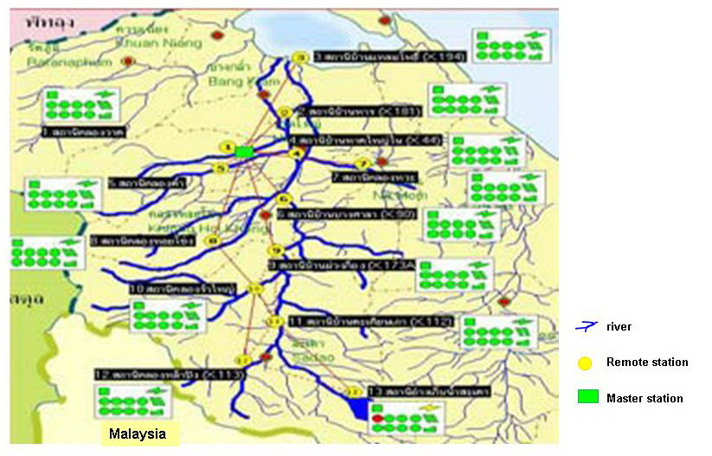
Hat Yai City

Figure 5 Telemetry system in Utaphao river basin

- Flood forecasting and warning system
The flood forecasting system is designed to link real-time hydrological and meteorological time-series data with detailed, accurate river basin modeling. This produces information about river level and flow forecasts in the shortest time possible after telemetry data are received. It is a standard platform for integrating a range of models, including catchment rainfall models, rainfall-runoff models, and hydrodynamic models, plus updating algorithms and tools for handling telemetry data and robustness to poor data quality.
The operational flood foresting system is based on a client server arrangement of computers, with all model forecasts being carried out on the central server computer (or dual server computers for robustness), typically situated in the operation control room, with forecast results being analyzed and then viewed on client computers.
The real-time telemetry system, as represented in the flood forecasting configuration, consist of: 13 raingauges; 17 flow gauges; 2 gate level gauges; 11 river level gauges.
This Utaphao basin configuration links the real-time telemetry data from the 13 raingauge to a set of sub-catchment raingauge averaging models. Rainfall and evaporation data are fed into sub-catchment rainfall-runoff models to provide boundary inputs to the complex hydrodynamic model of the main river reaches.
The Probability Distributed Model (PDM) is used in this system; it is fairly general conceptual rainfall-runoff model. Runoff production at a point in the catchment is controlled by the absorption capacity of the soil to take up water: this can be conceptualized as a simple store with a given storage capacity. By considering that different points in a catchment have differing storage capacities and that the spatial variation of capacity can be described by a probability distribution, it is possible to formulate a simple runoff production model which integrates the point runoff to yield the catchment surface runoff runoff into surface storage. The outflow from surface and subsurface storage, together with any fixed flow representing, say, compensation releases from reservoirs or constant abstractions, forms the model output.
Observed river level data, converted to flows, and observed reservoir outflow data, are used to underpin state-updating algorithms that have been calibrated to improve flow forecasts for each sub-catchment. These updating algorithms employ the techniques of state-correction in some cases, and ARMA (Auto-Regressive Moving Average) error prediction in others.
- The operational flood forecasting system for Hat Yai
The final configured operational system was installed in 2004. The FloodWork Server was located at the Royal Irrigation Department Southern Regional HQ in Hat Yai. This server was linked to a telemetry computer which receives all of the latest observed hydrological and hydraulic data from the Utaphao basin. Automated forecast simulations were set up, so that forecast simulations are carried out at regular intervals, ideally just after the telemetry system has been set up. A series of client computers, connected via leased line network connections to the main flood foresting server, were set up to display the results of the flood forecast simulations (Figure 6). The FloodWorks Event Manager clients are located at the following centres:
- Royal Irrigation Department Headquarters, Bangkok
- Royal Irrigation Department’s local basin office, Hat Yai
- Songkhla Province Administrative Office, Songkhla
Figure 6 Flood forecasting system for the Utaphao River Basin using the Floodworks software (MWH Soft)

- Flood forecasting by water level (state correlation)
Flood forecast and warning in Hat Yai town using discharge data collected at different points along the Utaphao Canal can provide flood warning in advance of 20 to 21 hours. The flood routing period is variable, according to the discharge in the Utaphao Canal. We developed statistical relationships between the flood peaks of two hydrological stations upstream of Hat Yai city and used this relationship to predict floods in the city (Figure 7). The two stations are X.173A (37 km above Hat Yai town) and X.90 (14 km. above Hat Yai town). The flood forecasting system using the statistical relationship is described in detail below.
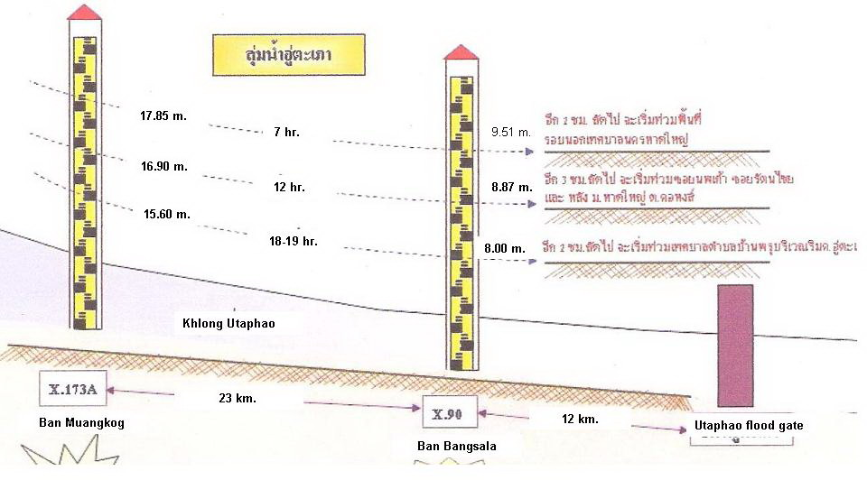

Figure 7 State correlation of Utaphao river for flood warning in Hatyai city

Step 1: Close monitoring of water levels
If water level at X.173A rises to 16.90 m (213 m³/s discharge), water will arrive Bangsala village (X.90) within 12 hours and rise to 8.87 m. (441 m³/s discharge). Water will move from X.90 to Utaphao water gate within 3 hours. The total time period for this to happen is 15 hours with a total discharge value of 620 m³/s.
Water management by 400 m³/s drainage along Utaphao Canal (water level in Hat Yai is 0.76 m. lower than the river bank) and 220 m3/s drainage along King Rama1 water way caused flood in some upper area of Utaphao water gate. The solution is water pump setting. This case didn’t affect flood in Hat Yai town.

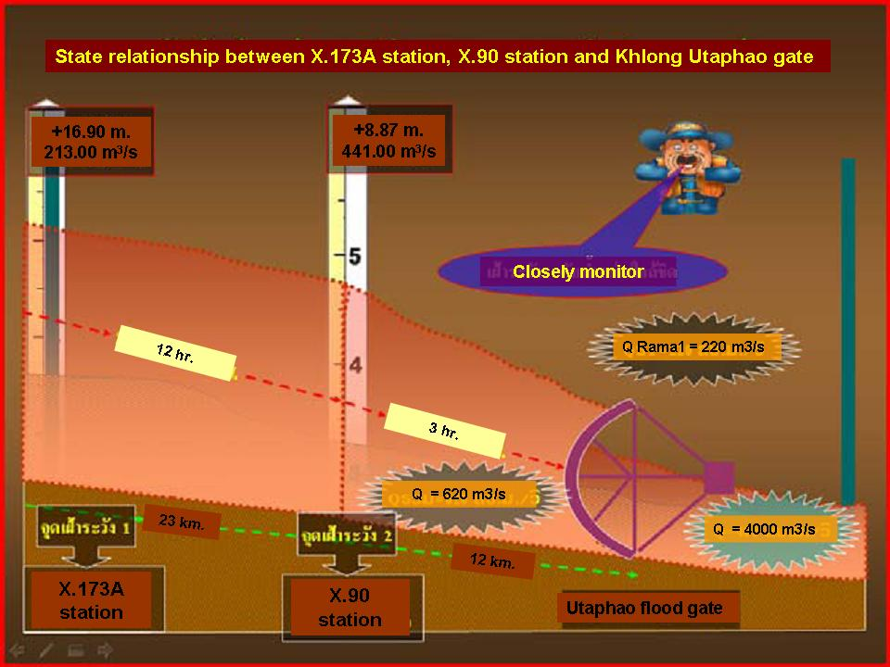
Figure 8 Stage relationship in case of close monitoring of water level
Step 2: Flood warning
If water level at X.173A rises to 17.85 m. (346 m3/s discharge), water will arrive X.90 within 7 hrs and water levels in the river will be 9.51 m high (774 m3/s discharge). Water will then travel from X.90 to Utaphao water gate within 2 hrs. The total travel period for the runoff will be 9 hours giving an advance warning period of 9 hours. The total runoff discharge for this situation is 930 m³/s. Floodwater management using the Utaphao Canal to drain away 465 m³/s (at its maximum capacity) and another 465 m³/s by the King Rama 1 waterway still resulted in floods in some areas around Hat Yai city since Hat Yai city is 0.29 metres lower than the river bank. A further solution to reduce the flooding problem in Hat Yai is to pump some of the floodwaters into Songkhla Lake. Although this measure prevented flooding at Hat Yai, flood warning and disaster preparation for the city is still needed in case flooding occurs in worse case scenarios.

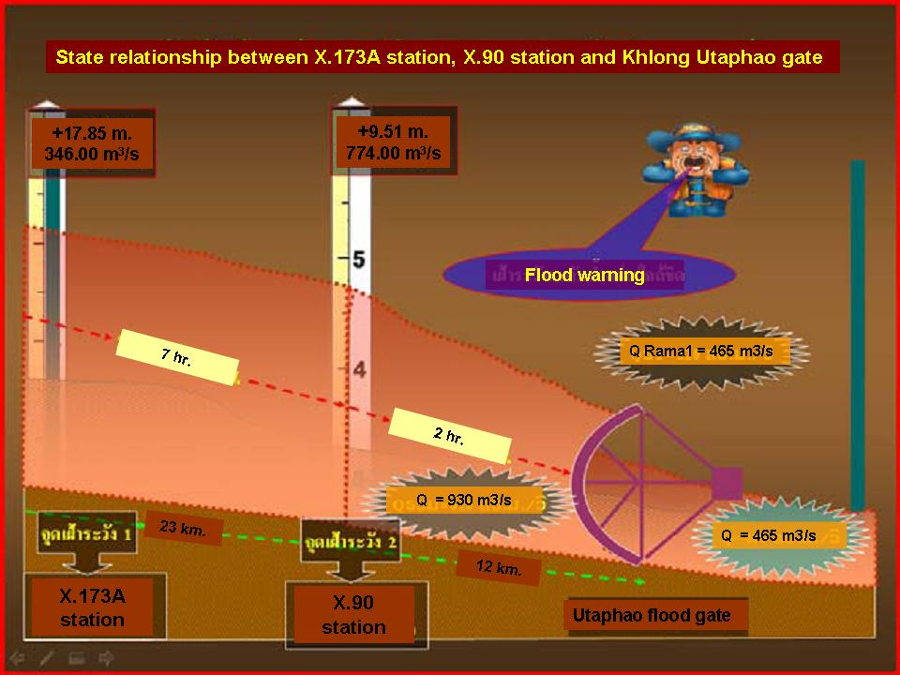
Figure 9 Stage relationship in case of Flood warning

- Water management for Hat Yai city and neighboring areas
- Water management by pump setting
Water pumping preparation is necessary during floods. These include areas within the river floodplain or within landuse areas that obstruct the flow of water in waterways (e.g. construction areas and landfills). The types of water pumps used at Hat Yai include permanent pumps as well as temporary pumps set up when their need arises, depending on the rainfall and flood situation. Their locations are shown in Figure 9. However, the designed drainage system alone cannot solve the problem in some areas subject to a high flood risk.
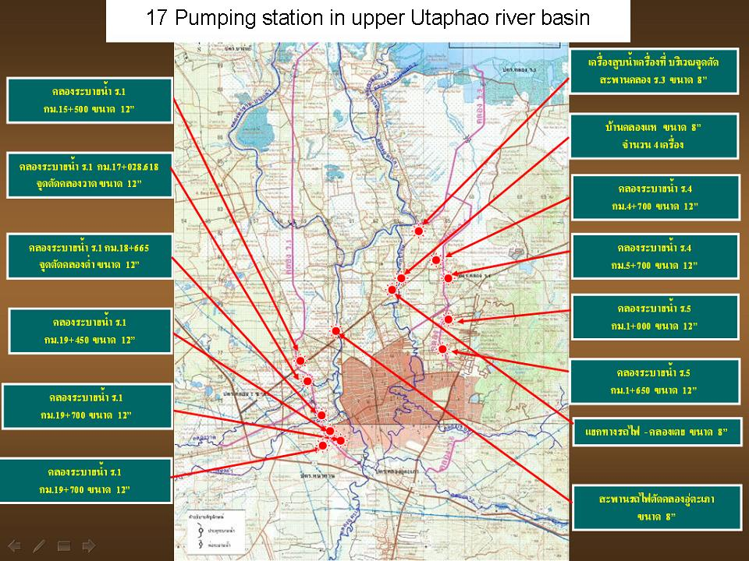

Figure 10 Locations of the 17 pumping stations around Hat Yai city

- Water management in cooperation with Hat Yai town and nearby municipality
The area experiencing the highest flood risk is the business area within the Hat Yai municipality. This area requires an improved water drainage system and flood protection system. Some measures to improve drainage and reduce the risk of floods include the following:

- Concrete water embankment on the left and right side of the canal are not at the same level. Understanding the design reason affects the efficiency of water management.
- Klong Rien monkey cheek: water release of the reservoir is important as it temporarily maintains the water flow in the canal (klong) during dry periods. Water management to control water flow is necessary especially during wet seasons or when the city and its surrounding areas experience high rainfall.
- Permanent water pump station: water gate and flood risk areas must be checked and prepared in case a flood occurs.
- Drainage system in town i.e. canal, drainage pipe must be in good drainage condition with no obstruction. In addition, we must get the cooperation of the local government to maintain the drainage system in town.
- Construct water gates and drainage systems to control floodwaters (e.g. Utaphao water gate in Kohong Municipality via Rama 1 drainage system)

- Climate Change and the Committee Activities
Royal Irrigation Department is aware of the reality of climate change and its potential impact on water resources management in Thailand. To address this issue, our plans for water resource development, management and water disaster prevention adopt a Green and Cold concept. This includes;

- Water source development

  - To review the design criteria

A change in climate impacts meteorology, hydrology and landuse patterns. To adapt to these changes, RID has to revise the design and acceptable risk values when dealing with water resources issues and water-related disasters.

  - Focus on multipurpose on water resource development
This involves the idea that the water resource is the same but the same resource has to be used in different ways under a changed climate to meet the needs of the country.

  - Conjunctive use of surface and ground water to that water supply meets water demand.

  - Improvement in water management to increase the potential of our water resources
This idea involves using our water resources in such a way that it does not result in environmental degradation but yield benefits to society and the economic status of the country.

- Water management

  - To review the reservoir operation rule.
There must be revision of reservoir operation rules and acceptable risk values under an altered climate.

  - Improvement of database system of water resources in Thailand.
Creation of this database allows the development of an integrated operation based on correct data management and exchange with other Government departments.

  - Improvement of cropping calendar and cropping pattern
A better understanding of climate change and its impact on agricultural activities is required to plan for water supply management.

  - Improvement of water supply measures and water loss
This involves in part an improvement in the irrigation system including using ways to reduce water loss to maximize the available water resources.

  - Improvement of water use efficiency.
With global warming, water disasters occur more severely and frequently. An example may be a change in the frequency and magnitude of floods as well as extreme water shortage during the dry season. In this case, improvement of water use efficiency is an important way to preserve our water supply.

- Construct suitable warning system in operation throughout a catchment
The use of real time monitoring coupled with flood forecasting and warning system is required to prevent loss of lives and properties during floods and other water-related disasters such as landslides.

- Adapt local knowledge with current understanding of climate change impacts.
We need to include local wisdom and technology together with the latest scientific knowledge about environmental processes and engineering knowledge to deal with climate change.

III. Benefits of typhoons
In Thailand, the negative impacts of typhoons generally outweigh the benefits. Typhoon-related flooding and other disasters have a severe impact on the country’s economy through loss of property, crop and lives especially when their frequency and magnitude changes with an altered climate. However, it is possible that when typhoons do not hit Thailand so severely, they bring rainfall which may be beneficial for crop growth and an increase in water resource that can be stored (either in the soil or in a reservoir) for use during the ensuing dry season. The sediment brought by floodwaters may actually help increase productivity of lowland areas by providing a fresh source of sediment. Much more research is needed to better understand the effects and impacts of typhoons on Thailand’s physical, socio-cultural and economic environment.

IV. Review of the progress in the implementation of the Committee Strategic Plan and its Annual Operation Plan for 2010.
We would like to present two main activities that are related to the Hydrological Component of the Annual Operation Plan for 2010.
- Urban Flood Risk Management (UFRM)
We will present RIDs efforts on urban flood risk management using the example of Hat Yai City, South Thailand.
- Assessment System of Socio-economic Impacts of Water-related Disasters for Infrastructure
This topic will be addressed in future RID projects
- Hazard Mapping for Sediment Disasters
Case study 2: Hazard mapping of sediment disasters, Phetchabun Province, North Thailand
We present a case study of hazard mapping for sediment disasters using the example of a study conducted in Nam Koh and Nam Chun catchments in Phetchabun Province, North Thailand.
This study looks at a flash flood and mudslide event that occurred on 11 August 2001 for two small catchments in Phetchabun, North Thailand. The two catchments are Huai Nam Ko (73 km²) and Huai Nam Chun (67 km²) catchment which are both adjacent to each other. Cross-sectional surveys, Manning’s formula and the Unit Hydrograph were used to estimate the flood peak, flood volume and flood-causing rainfall amount for both catchments in the absence of rainfall and runoff data. The peak flow for the Huai Nam Chun and Huai Nam Ko catchments were 603 m³s⁻¹ and 765 m³s⁻¹ with a corresponding flood volume of 3.04 million m³ and 3.84 million m³ respectively. The rainfall amount that caused flooding is low compared to typical rainfall events experienced during the monsoon season; 45.4 mm and 52.6 mm for the Huai Nam Chun and Huai Nam Ko catchments respectively. These catchments are particularly vulnerable during the monsoon season since slight heavy rainfall may result in flooding and landslides that cause a loss of property and lives.
- On-the-Job Training on Flood Forecasting between Member
RID does not have any trainee to participate with the On-the-Job training on Flood Forecasting but we will appreciate any knowledge/technology transfer or training in this area from other Member countries.

    - Review the Strategic Plan 2007-2011 with a view to prepare a draft of Strategic Plan 2012-2016 to submit to the Forty third Session for consideration.
In progress.

